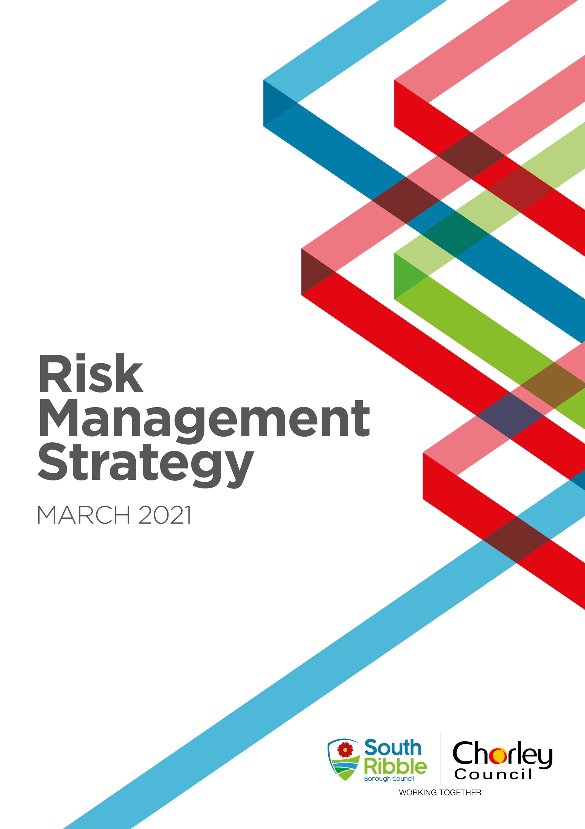

INTRODUCTION

Welcome to the Risk Management Strategy, refreshed in March 2021. The aim of the Strategy is to improve strategic and operational risk management throughout the Council. Effective risk management allows the Council to:

- have increased confidence in achieving its corporate objectives

- mitigate threats to acceptable levels

- take informed decisions about exploiting opportunities

- ensure that it gets the right balance between rewards and risks

- improve its partnership working arrangements and corporate governance

Effective risk management will help to ensure the Council maximises its opportunities and minimises the impact of the risks it faces, thereby improving its ability to deliver its core objectives and improve outcomes for its residents.

This strategy explains the approach to strategic and operational risk management, and the framework that it will operate to ensure that it arranges its risks effectively.

RISK MANAGEMENT: OBJECTIVES

We are exposed to risk both in terms of threats to service provision and from missed opportunities. It is essential that we can demonstrate to our residents that we are fully considering the implications of risk as we plan and deliver services to the community.

Like all organisations, the Council exists to achieve its objectives which are set out in our Corporate Plan. Risk management can help us achieve these goals by fully considering the opportunities and barriers that we may encounter. Our aim is to use strategic risk management as a tool for continuous improvement and to make effective use of the Council resources.

In addition, the Council must also ensure operation and delivery of services, the health and safety of its service users, employees and the public at large. This Risk Management Strategy supports continuing change including partnership working and alternative methods of service delivery and provides a structured and focused approach to managing them.

Effective risk management also helps services focus on what actions can be taken to deal with future events. Risk management can help the Council plan to deal with the scale and speed of changes in Government policy and financial challenges. Having assessed risk and planned for the known challenges also means that when the unanticipated or unexpected arise, as they no doubt will, there is greater management and Member capacity across the Council to respond quickly and effectively.

This Strategy outlines how the Council is taking on its responsibility to manage risks and opportunities using a structured and focused approach.

WHAT IS RISK MANAGEMENT?

Risk management can be defined as:

“Risk management is the logical and systematic method of identifying, analysing, evaluating, treating, monitoring and communicating risks associated with any activity, function or process in a way that enables organisations to minimise losses, maximise opportunities and achieve their objectives.”

Risk management is a strategic tool and is an essential part of effective and efficient management and planning. Risk management is also an essential part of CIPFA’s Delivering Good Governance in Local Government Framework. The Framework requires the Council to make a public assurance statement annually, on amongst other areas, the Council’s risk management strategy, process and arrangements. As required by the Accounts and Audit Regulations 2015 the assurance statement is disclosed in the Annual Governance Statement and is signed by the Leader of the Council and the Chief Executive.

RISK MANAGEMENT APPROACH

The Council seeks to embed risk management into its culture, processes and structure to ensure that opportunities are maximised. The Council will seek to encourage managers to identify, understand and manage risks, and learn how to accept the right risks. Adoption of this strategy must result in a real difference in the Council’s behaviour.

The Council is prepared to take cautious risks to achieve its corporate objectives and enhance the value of the services it provides to the community. Its aims are to:

- Ensure risk management is integrated into the culture of the Council.
- Ensure appropriate risk taking is encouraged, particularly to respond to opportunities arising.
- Anticipate and respond to changing social, environmental and legislative needs, pressures or constraints, as well as changes in the internal environment.
- Manage risk in accordance with best practice including integration with performance and financial management including partnership arrangements.
- Improve performance and efficiency and in particular minimise injury, damage and losses and make effective use of resources.
- Protect the Council’s assets, reputation and operational capacity.

These aims will be achieved by:

- Maintaining clear roles, responsibilities and reporting lines for risk management.
- Raising awareness of the need for risk management by all those connected with the Council’s delivery of services.
- Gaining commitment from all members and employees, to ensure risk is managed within a consistent framework.
- Ensuring that risk management is explicitly considered in all decision making by, incorporating links to all key decision points e.g. committee reports, delegated decisions, project management and partnership agreements.
- Considering risk in all the Council’s key planning processes.
- Providing opportunities for shared learning on risk management across the Council and with our business partners.
- Reinforcing the importance of effective risk management as part of the everyday work of members and employees.
- Providing adequate assurance for the management of risk to support the Annual Governance Statement.

RISK MANAGEMENT PROCESS

Implementing the strategy involves identifying, analysing, managing and monitoring risks, this process is outlined below and summarised in Appendix 1.

Risk Identification

The GRACE (Governance, Risk Assessment and Control Evaluation) system has been adopted for use within the Council to enable the completion of risk registers at all levels including the Strategic Risk Register, Service Risk Registers, projects, key procurements, partnerships and processes.

Risks and opportunities can be identified at any time and should be included within GRACE. There are numerous ways in which risks and opportunities can be identified, including networking, articles / newsletters, training courses as well as discussions at team meetings and 1-2-1s.

In addition, GRACE contains a large database of model risks and controls in the Profile Library which users can scroll through to identify any which may be relevant to their areas of activity.

Risk Recording

The Council maintains registers for different types of risks:

Strategic risk register – This contains the high-level risks of the Council. It is owned and maintained by the Council’s Senior Management Team and is kept under continuous review and is regularly presented to the Governance Committee and Cabinet.

Operational/Service risk registers – These include service, business planning, project, partnerships and process risks. These are assigned to specific Directors, Assistant Directors, and Service Leads who have overall responsibility for their maintenance and continuous review on the GRACE system. They can allocate individual risks to risk owners who must decide upon and monitor appropriate actions.

The specific information to be recorded in GRACE is as follows:

Risk description – this requires an understanding of the legal, social, political and cultural environment in which the Council operates as well as a sound understanding of the Council’s corporate and operational objectives i.e. those factors which are critical to the success of the Council, as well as threats and opportunities.

Risk Owner – a nominated person who is responsible for evaluating and responding to any individual risks allocated to them.

Assessment of Risk (Gross Risk Score) – having identified areas of potential risk, they need to be systematically and accurately assessed. The process requires managers to assess the likelihood and potential impact of a risk event occurring and scored according to the matrix below:

Impact | 4 | Major | 4 | 8 | 12 | 16
 | 3 | Serious | 3 | 6 | 9 | 12
 | 2 | Minor | 2 | 4 | 6 | 8
 | 1 | Insignificant | 1 | 2 | 3 | 4
 |  |  | 1 | 2 | 3 | 4
 |  |  | Rarely | Unlikely | Likely | Highly Likely
 |  | Likelihood

The following tables provide assistance in assessing the likelihood and impact of risks and will enable the risk owner to determine the Gross and Residual risk score from the matrix.

Likelihood Definitions:

1 – Rarely | Highly unlikely, but it may occur in exceptional circumstances. It could happen but probably never will.
2 - Unlikely | Not expected, but there’s a slight possibility it may occur at some time
3 – Likely | The event might occur at some time as there is a history of casual occurrence and / or similar organisations
4 – Highly Likely | It is almost certain the event will occur as there is a history of frequent occurrence and / or similar organisations

Impact Definitions:

1 -Insignificant | Minimal financial loss. No or only minor personal injury. Systems unavailable for less than an hour. Possible impact, but manageable locally by Managers. No reputational impact. No legal action.
2 - Minor | £1000 - £25,000 financial impact manageable within service budget. Minor injury requiring medical treatment. Systems unavailable for most of a day. Possible impact but manageable locally by Director. Possible negative customer complaints with low level adverse media coverage. Legal action possible but unlikely and defendable.
3 - Serious | £25,000 - £100,000 financial impact manageable within Directorate budget but requiring approval for virement or additional funds. Possible hospitalisation with long-term injury or long-term sick. Systems unavailable for more than 1 day. Expected impact, but manageable within existing Directorate contingency plans. Adverse national media coverage. Negative customer complaints. Legal action expected. Breaches of Codes of Practice, Professional Ethics. Non-Compliance with regulation/standards or local procedures resulting in disciplinary action.
4 - Major | £100,000+ financial impact not manageable within existing funds and requiring Member approval for virement or additional funds. Death/life threatening or long-term illness or multiple injuries. Systems unavailable for multiple days. Serious impact felt across more than one Directorate. Adverse and extended media coverage. Legal Action almost certain and difficult to defend. Non-compliance with law resulting in imprisonment.

Existing Control Measures – any controls or measures that reduce the likelihood or impact of a risk.

Residual Risk Score – this risk score which takes account of any existing control measures in place (see above matrix).

Risk Categories – risks should be assigned to one of the categories listed below:

- Strategic – risks impacting upon the achievement of the corporate objectives and priorities;
- Financial – risks associated with financial planning and control;
- Human Resources – risks associated with recruiting, retaining and motivating staff & developing skills;
- Environmental – risks related to pollution, noise or energy efficiency;
- Information – risks related to information held;
- Legal / regulatory – risk relating to legal / regulatory requirements;
- Operational – risks relating to operational activity;
- Partnership / Contractual – risk relating to the failure of partners / contractors or the contract itself;
- Physical – risk related to fire, security, accident prevention & health and wellbeing;
- Reputational – risk relating to the reputational risk to the Council;
- Technological – risks associated with technology.
- Fraud – risks associated with fraud and corruption

Control Strategy – in broad terms there are four main options for responding to risks which remain within the organisation.

Terminate - this involves the Council in terminating the cause of the risk or, opting not to take a current or proposed activity because it believes it is too risky.

Tolerate - this is where the cost of action outweighs the benefit that results from the proposed action. Alternatively, no further action can be taken and the risk is accepted with any potential financial loss being highlighted.

Transfer - this involves transferring liability for the consequences of an event to another body. This can occur in two forms. Firstly, legal liability may be transferred to an alternative provider under contractual arrangements for service delivery. Secondly, transferring some or all the financial risk to external insurance companies may reduce the costs associated with a damaging event.

Treat - this is dependent on implementing projects or procedures that will minimise the likelihood of an event occurring or limit the severity of the consequences should it occur.

The target risk score therefore may be the same or lower than the residual risk score and reflects the level of risk the Risk Owner is willing to accept (see above matrix).

Risk Actions – where further treatment of the risk is deemed necessary then the Risk Owner will determine the course of action to be taken. The action to manage risk needs to be appropriate, achievable and affordable. The impact expected if no action is taken should be considered against the cost of action and the reduction of the impact. For opportunities, the benefit gained in relation to the cost of action should be considered.

RISK MONITORING

Individual risks are reviewed in accordance with GRACE parameters depending upon the level of risk:

Red risks | 3 months
Amber risks | 6 months
Green risks | 12 months

The Corporate Governance Group will monitor risk reviews and implementation of actions to ensure they are being undertaken and risks considered in a timely manner. Slippages in risk reviews / non implementation of actions will be escalated to Directors.

The overall risk management system is reviewed by Internal Audit as part of their annual audit work plan. In accordance with the Public Sector Internal Auditing Standards the Chief Audit Executive’s (Shared Service Lead – Audit and Risk) Annual Report is required to provide an opinion based on an objective assessment of the framework of governance, risk management and control.

Risk management assurance will also be published in the Council’s Annual Governance Statement.

RISK TRAINING

Training and raising awareness are an important means of ensuring risk management is embedded within the culture of the organisation. Every individual will encounter risk at some level, whether strategic or operational and we all have a responsibility for ensuring risks are well managed. It is therefore important that a range of training opportunities are available for employees and members.

The Audit and Risk Service is responsible for ensuring training (including refresher training) and awareness raising is periodically undertaken. Training may range from use of the Learning Hub to individual one to one training.

RISK REPORTING

The Strategic Risk Register is continuously monitored by the Council’s Senior Management Team and regularly reported to Governance Committee and Cabinet.

Service Risk Registers and those in relation key projects, procurements, partnerships and processes are monitored by Directors, Assistant Directors and Service Leads.

GRACE has also enabled a risk-based approach to internal auditing by engaging service departments in the self-assessment of their own system risks via the completion of on-line risk registers prior to the commencement of audits. System/process risks are reported as part and parcel of ongoing Internal Audit work.

Finally, all Committee reports, Cabinet decisions taken under delegated powers and corporate projects, including partnership agreements include the consideration and control of the risks associated with the actions proposed.

ROLES & RESPONSIBILITIES FOR RISK MANAGEMENT

The following describes the roles and responsibilities that members and officers will play in introducing, and embedding the risk management process: -

The Council will approve the Constitution including the system of corporate governance which incorporates risk management arrangements.

The Governance Committee will, in accordance with the Terms of Reference, continuously review the Risk Management Strategy and monitor the effective development and operation of risk management in the Council; and will monitor progress in addressing risk related issues reported to the committee.

The Chief Executive has overall responsibility for risk management in conjunction with the Council’s insurers for supporting risk management.

The Section 151 Officer will, through the Internal Audit Service, provide assurance to the Council on the whole system of internal control, including risk management.

Audit and Risk Service in line with their responsibilities for the Council’s corporate governance arrangements will lead the risk management initiative and ‘champion’ risk management by supplying advice and data to Directors.

Internal Audit, as part of its role in providing assurance to the Section 151 officer, will review the implementation and effectiveness of the system of risk management. An annual report will provide independent opinion on the adequacies of risk control and the Council’s corporate governance arrangements and also risk management is included within the review of the Annual Governance Statement. Internal Audit will act as a centre of expertise, providing support and guidance as required and will collate risk information and prepare reports as necessary to both the Leadership Team, and the Governance Committee. The Internal Audit work plan is focused on the key risks facing the Council and during all relevant audits, it challenges the content of risk registers.

Internal Audit will periodically arrange for the independent review of the Council’s risk management process and provide an independent objective opinion on its operation and effectiveness.

Senior Management Team will consider and evaluate those risks contained within the Strategic Risk Register, likely to have a significant impact on the Council’s objectives.

Directors/Assistant Directors and Service Leads will identify and manage risks in their service areas. With their own teams they will identify and evaluate the risks associated with service improvement and those risks which may prevent them from achieving their service objectives.

Project / Procurement Managers have a responsibility to ensure that the risks associated with their projects / procurements are identified, recorded on GRACE and regularly reviewed as part of the project management process and provide assurance about the management of those risks.

Partnerships – client officers have a responsibility to ensure that risks are identified, owned, recorded on GRACE are reviewed and shared with all relevant partners and ultimately to provide assurance that those risks are being managed.

Employees’ responsibility for managing risk is not restricted to any one person or group of specialists. All employees have a responsibility to manage risk effectively in their job and report opportunities, threats and risks to their Directors and undertake their duties within risk management guidelines. Those officers involved in decision-making should also explicitly consider the implications of risk management and document their findings appropriately.

Appendix 1
Treat Risk

Plan actions that target the
cause of the risk and/or
reduce the potential impact

Describe Risk

What can happen?

How can it happen?

Assess Risk

Determine existing controls

Determine
Likelihood

Determine
Impact

Estimate level of
residual risk

Evaluate Risk Options

Consider the 4 “T”s

Tolerate Risk

Where costs of action
outweigh potential benefits or
nothing further can be done
to reduce the level of the
threat.

Transfer Risk

Insure against the risk or
transfer

to a third party e.g. a
contractor or partner who is
better able to manage the
risk

Monitor and Review

Terminate Risk

Quick, decisive action,
fundamental change e.g.
revise strategy, revisit
objectives or stop the activity

Communicate and consult

